Manila Water CompanyCustomer NameDocument Title

FUNCTIONAL SPECIFICATION – ENHANCEMENT

DID_R2R_180

Process Payment Acknowledgements Files
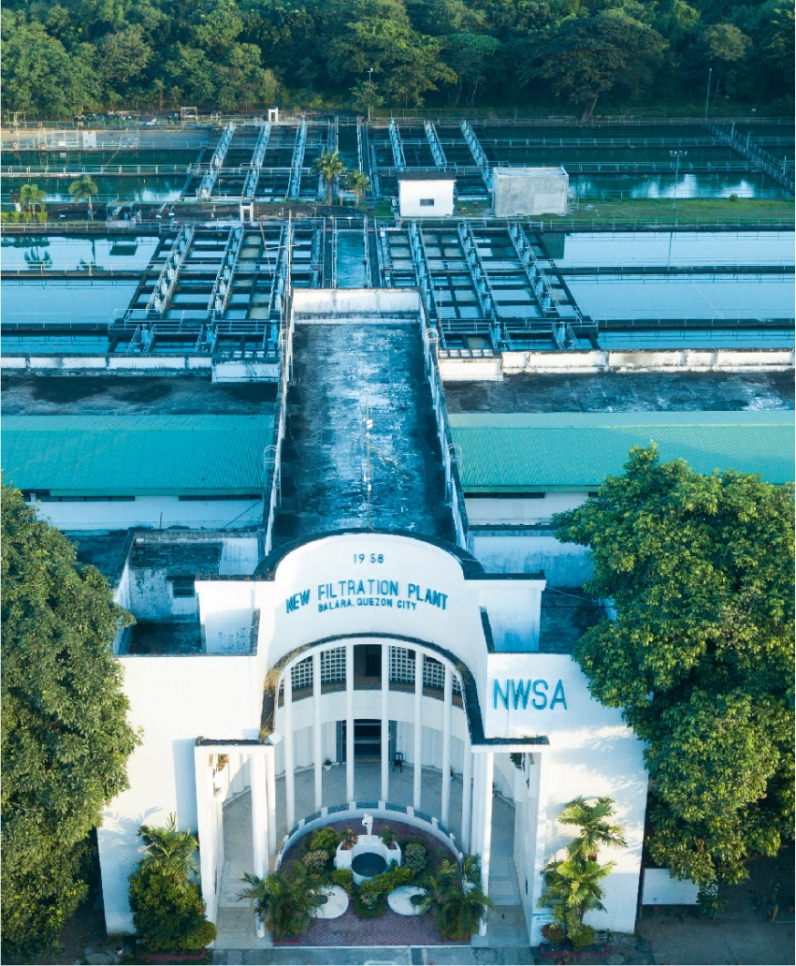





Contents
1 Document Organization 3
1.1 Document Log 3
1.2 Integration, Document Reference 3
2 Justification 3
3 Functional Description 4
4 Security / Authorization Requirements 7
4.1 Definition 7
4.2 Defined Fields 7
4.3 Procedure 7
5 Dependencies / Constraints 7
6 Assumptions 7
7 Security Requirements 7
8 Functional Requirement 7
8.1 Flow of Enhancement 8
8.2 Layout 8
9 Assumptions in Functional Design 8
10 Open Issues in Functional Design 8
11 Business Test Conditions 8
12 Related Documentation 9

Document Organization
This section provides details about this document, previous version(s) of this document and the document(s) referred.

Document Log
Following table mentions the version changes and the processer(s):
Version | Status | Date | Version Created by (Name/E-Mail/Company) | Role | Comments
0.1 | Draft | December 5, 2024 | Ravi Yadav  ravi.yadav@sap.com | Author | Initial draft
0.2 | Ready for Review | December 10, 2024 | Roopali Sharma  roopali.sharma02@sap.com  Mohanrangan  Mohanrangan.rangarajan@sap.com | Reviewer | Technical Review
0.3 | Ready for Review | March 6, 2025 | Ravi Yadav  ravi.yadav@sap.com | Author | Additional requirements.
0.4 | Ready for Review | March 12, 2025 | Roopali Sharma  roopali.sharma02@sap.com  Mohanrangan  Mohanrangan.rangarajan@sap.com | Reviewer | Technical Review
0.5 | Reviewed with Comments | March 18, 2025 | MWC Product Owners  Value Delivery Leads | Reviewer | Business Review

Integration, Document Reference
S. No. | Referred Document Name | Referred Document Version | Referred Document URL (Optional)
1 | MWC_SDD_TRM_02_Basic Cash Operations | Final V2.0
2 | MWC_DID_R2R_173 to 178 - Inbound & Outbound Interfaces with Banks | Final V1.0

The documents listed here are explicitly not part of this Functional Specification. They are not automatically accepted together with this Specification but may be subject to separate customer/SAP acceptance.

Justification
During the payment processing, once the payment instructions files are sent to the external banks from ERP system, they are processed by banks for payment purposes, and corresponding payment processing reports in terms of acknowledgements (as per successful processing or any errors during payment processing) as response to payment files are sent back to the business by banks.
Then, depending on the status of payments, the payment documents in the ERP system are updated appropriately. For instance,
- Automatically reverse the payment documents in case of Rejection,
- Update cheque no. or other fields (such as Assignment, Reference) in the payment documents in case of Successful processing

As part of Advanced Cash Management, the payment acknowledgement files in globally accepted formats (like PAIN.002) are processed using report RBNK_IMPORT_PAYM_STATUS_REPORT or transaction SXMB_MONI which update the status of the payment batch.

However, in MWC, Advanced Cash Management is out of scope. Also, the business does not receive the payment acknowledgement files in globally accepted formats i.e., PAIN.002. MWC requires status update in S/4 (mainly payment document reversals) as per received acknowledgement files from SCB and RCBC banks.

Thus, an enhancement is required to develop a program for the processing of acknowledgment files in MWC specific formats. This document captures the essential technical details like input screen, AL11 directories, and processing logic to process the payment acknowledgement files.

Functional Description
In MWC, there are 3 types of acknowledgement files sent by banks which require corresponding status update in S/4 system: -
- BANSTA
  - RCBC: .txt files (comma separated)
  - SCB: .csv files (comma separated)

- Acknowledgment Files (Accepted, Rejected)
  - SCB: .txt files (pipeline delimiter)
  - RCBC: .txt files (pipeline delimiter)
- Stale Cheque Reports
Cheques are printed by SCB and RCBC banks as per sent payment instructions files which are thereafter collected from banks by respective beneficiaries. For the cheques not picked by beneficiaries,
  - SCB Bank:
    - Shares file every month for the cheques issued 1 year ago, but not yet collected by the beneficiaries.
    - File Format: .xls
  - RCBC Bank:
    - Shares file every month for the cheques issued 1 year ago, but not yet collected by the beneficiaries.
    - File Format: .xls

SCB and RCBC banks share the above files in their respective formats. For technical details regarding processing of the received files, refer Heading – Functional Requirement.

Security / Authorization Requirements
The custom transaction codes and Fiori tiles created for this enhancement will be assigned to the appropriate business role which will then be assigned to the corresponding business accountants as per MWC specific Roles & Authorization Matrix. This business role will be updated here post the conclusion of Roles & Authorization matrix.
- Fiori App: MWC Process BANSTA Files (ZTRM_BANSTA)
- Fiori App: MWC Process Acknowledgement Files (ZTRM_PAYACK)
- Fiori App: MWC Process Stale Cheque Reports (ZTRM_STALECHQ)

Definition
Standard / Custom Authorization Object:

Defined Fields
Not Applicable.

Procedure
Not Applicable.

Dependencies / Constraints
- H2H interfaces with banks for inbound messages. (DID_R2R_173 to DID_R2R_178). The inbound interfaces will automatically transfer the applicable inbound messages from banks to relevant AL11 directories.
- Payment Reversal Reasons: Financial Accounting > Accounts Receivable and Accounts Payable > Business Transactions > Outgoing Payments > Automatic Outgoing Payments > Payment Media > Check Management > Define Void Reason Codes
No batch job is applicable here.

Assumptions
- The layout and format of the payment acknowledgement files (i.e., sequence of rows as well as columns including blank rows or columns) will remain consistent as per shared sample files. Any deviation in the file formats will necessitate changes in custom program.
- Stale Cheque Report is received via email as well as via H2H interfaces. Thus, custom program is to address both the scenarios.
- These programs to process the acknowledgment files will be scheduled as background jobs. Also, the business user can execute them manually, if required.
- The file format of Stale Cheque Report of both SCB and RCBC banks is same.

Security Requirements
Not Applicable.

Functional Requirement
Input Screen (Screen 1)
S. No. | Field Name | Select Option | Parameter | Mandatory or Optional
1 | Payment Acknowledgement File type | radio button Group | Process payment acknowledgement files  process stale cheque report (SCB) | M
1 | File directory | F4 Help | AL11 Directory Structure or  Local desktop | M
2 | Upload file | F4 Help | File from directory structure above | M
Background jobs, with suitable variants, will be created for the processing of each type of payment acknowledgement files with frequency to run daily at 6 AM.

The custom program is to
- automatically fetch all files from AL11 directory if ‘Upload File’ is left blank (Input folder)
- User can manually upload a file as well
- Upon successful processing, file is to be moved to ‘Archive’ folder along with processing log (having name same as the file name)
- In case of any error, the file is to be transferred to ‘Error’ folder along with processing log (having name same as the file name)

Scenario 1: Process BANSTA Files
AL11 Directory Structure of Inbound Messages
- <rootdir>/Inbound/Input/TRM/PAYACK/BANSTA/SCB/
- <rootdir>/Inbound/Archive/TRM/PAYACK/BANSTA/SCB/
- <rootdir>/Inbound/Error/TRM/PAYACK/BANSTA/SCB/
- Similarly, for RCBC bank

These are comma separated files. The business requirement is to read the payment documents numbers in the BANSTA file,
- Reverse the payment document in case status <> ‘Processed’
- Update cheque number in the payment document in case status = ‘Processed’
- Read the text field and update it in the Assignment field of the payment document

Processing logic: -
- Read all line items starting with “D”
- Pick payment document (2nd column), status of processing of payment document (4th column) and posting date (5th column)
- If Status <> Processed, call transaction FBRA (Reset & Reverse) to reverse the payment document and pass
  - Payment document
  - Company Code: 6th column (SCB) or 10th column (RCBC) from the end mentions the Account Number. Refer table T012K to pick the Company Code.
  - Fiscal Year: Derive from posting date
  - Reversal Reason = TBD
  - Posting Date: Posting date
- If Status = ‘Processed’, update cheque number (3rd column from end-of-line) in the payment document,
  - Pass Payment Document into table REGUH for the Company Code (ZBUKR) and Posting Date as Posting Date of Payment Document (ZALDT), and pick Payment Method (RZAWE)
  - If Payment Method IS IN THE SET (ZTRM_CHQ_PYMT_METH = CNOR), pass following inputs in the transaction FCH5
    - Payment document
    - Company Code: 6th column from the end
    - Fiscal Year: Derive from posting date
    - House Bank & Account ID:
      - Pass Company Code, Payment Document, Fiscal Year into table ACDOCA where Ledger = 0L and Account Type = S, and pick House Bank and Account ID
    - Check Number
  - Else, EXIT.

Scenario 2: Process Payment Acknowledgment Files (Accepted / Rejected)
AL11 Directory Structure of Inbound Messages
- <rootdir>/Inbound/Input/TRM/PAYACK/PAYACK/SCB/
- <rootdir>/Inbound/Archive/TRM/PAYACK/PAYACK/SCB/
- <rootdir>/Inbound/Error/TRM/PAYACK/PAYACK/SCB/
- Similarly, for RCBC bank

These are delimited files with pipeline separator. The business requirement is to read the acknowledgement files,
- If value in 1st column = ACK3, no action other than putting file in the Archive folder.
- If value in 1st column = REJ3, reverse all the payment documents in a Run Date and Run ID.

Processing logic: -
- Read 3rd column for string ‘PAIN001’ (Naming convention of payment file: PAIN001_RUNDATE_RUNID_DateStamp.xml)
- As per naming convention above, pick Run Date and Run ID
- Pass Run Date (LAUFD) and Run ID (LAUFI) into table REGUH, and pick Company Code (ZBUKR), Payment Document Number (VBLNR) and Posting Date of Payment Document (ZALDT) where Indicator: Only Proposal (XVORL) = BLANK
- Reverse all the payment documents using transaction FBRA (Reset & Reverse) and pass
  - Payment document number
  - Company Code
  - Fiscal Year: Derive from Posting Date of Payment Document
  - Reversal Reason = TBD
  - Posting Date: Posting Date of Payment Document

Scenario 3: Process Stale Cheque Reports
AL11 Directory Structure of Inbound Messages
- <rootdir>/Inbound/Input/TRM/PAYACK/STALECHQ/SCB/
- <rootdir>/Inbound/Archive/TRM/PAYACK/STALECHQ/SCB/
- <rootdir>/Inbound/Error/TRM/PAYACK/STALECHQ/SCB/
- Similarly, for RCBC bank

These are .xls files. The business requirement is to read the Cheque Numbers in the file and thereafter cancel the cheque payment and reverse the respective payment documents to which these cheque numbers are attached.

Processing logic: -
- Pick Cheque Number (column 1) from the file
- For the ‘Account No.’, read table T012K and pick Company Code, House Bank and Account ID.
- Pass Company Code, House Bank, Account ID and ‘Cheque Number’ (CHECT) into table PAYR, and read Payment Document Number (VBLNR)
- Call transaction FCH8, and
  - Bank Data Section: Pass Company Code, House Bank and Account ID
  - Cheque Payment to be Reversed Section: Pass Cheque Number and Void Reason Code = Z1 (Stale Cheque). This will cancel the issued cheque.
  - Reversal Data Section: Reversal Reason = 01 (Reversal in Current Period) and Posting Date = System Date. This will reverse the corresponding payment document.
- Processing Log: Display the file inputs on screen along with processing status of each line.
  - Payment Document Reversed
  - No Clearing Document Found or error message, as applicable

Flow of Enhancement
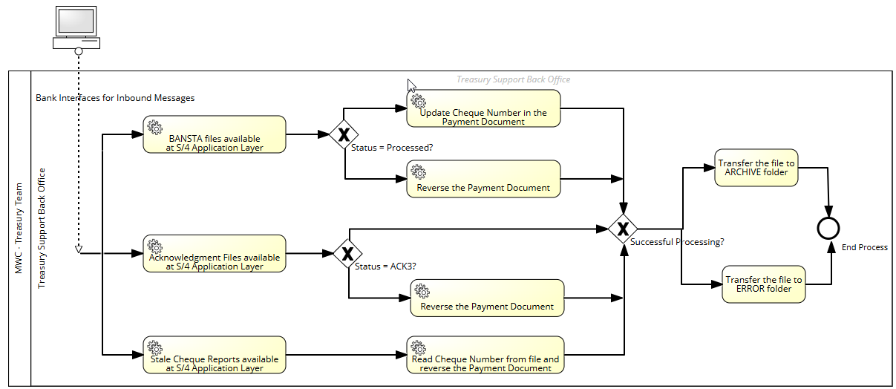

Layout
Not Applicable.

Assumptions in Functional Design
Not Applicable.

Open Issues in Functional Design
- List of possible rejection reasons, so that appropriate Reversal Reasons can be configured.
- Stale Cheque Report: Accounting entry for the credit line items, corresponding to Stale Cheques, in the received MT940. Whether Note To Payee has details to identify such stale cheque credit line items. Any enhancement required in this process will be covered using Gap ID DID_R2R_181.
- BANSTA files of cheque and non-cheque payments to identify “where is the cheque number”
- With SCB bank, explore the possibility of receiving Stale Cheque report via H2H interfaces.

Business Test Conditions

Scenario # | Input Selection Criteria | Expected Result
1 | Process Stale Cheque Report of SCB Bank | Cheque payment is cancelled.  Payment document is reversed.
2 | Process Stale Cheque Report of RCBC Bank | Cheque payment is cancelled.  Payment document is reversed.
3 | Process BANSTA File of SCB Bank | Payment document is reversed if Status <> Processed.  Cheque Number is updated in the Payment Document if Status = Processed
4 | Process BANSTA File of RCBC Bank | Payment document is reversed if Status <> Processed.  Cheque Number is updated in the Payment Document if Status = Processed
5 | Process Acknowledgement Files (Rejection) of SCB Bank | Payment documents are reversed.
6 | Process Acknowledgement Files (Rejection) of RCBC Bank | Payment documents are reversed.

Related Documentation
- MWC_SDD_TRM_02_Basic Cash Operations
- MWC_DID_R2R_173 to MWC_DID_R2R_178 - Inbound & Outbound Interfaces with Banks

Approach to reverse the payment documents
- Function Module CALL_FB08 (using SE37) or CALL_FBRA is used for document reversal.
  - Don't pass a value to I_UPDATE (A - asynchronous update (default); S - synchronous update; L - local update) and I_XSIMU, FM uses the default values.
  - AUGBL – Clearing Document; AUGDT – Clearing Date;
- Program RFF110S_REVERSE: To reverse all payment documents of F110
- F.80 / F-08: Mass Reversal of accounting document

Approach to Void the Cheque
Use t-code FCH9 or Function Module FCH9_VOID_CHECK to void a check.

